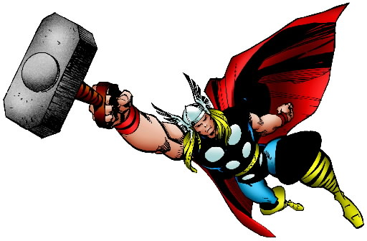
Thor Donald Blake [Secret]

Affiliations
Solo
Buddy
Team
Distinctions

God of Thunder
Lead by Might
Struggle with Humility

XP: ___ _ PP: ____

Power Sets
Champion of the Gods
Godlike Durability Superhuman Stamina Godlike Strength

SFX: Berserk. Borrow a die from the doom pool for an attack action. Step up the die by +1 and return to the doom pool
SFX: Invulnerable. Spend 1 PP to ignore physical stress or trauma results unless caused by magical attacks.
SFX: Take the Hit. Spend 1 PP to take physical stress intended for a nearby ally friend.
Limit: Asgardian. Earn 1 PP to step up emotional or mental stress inflicted by immortals and their agents by +1.
Mjonir
Electrical Blast Superhuman Durability Supersonic Flight
Weapon Weather Supremacy
SFX: Area Attack. Target multiple opponents. For each additional target, add d6 to your pool and keep +1 effect die.
SFX: Electrical Absorption. On a successful reaction against an electricity based attack action, convert opponent’s effect die into a Mjonir stunt or step up Electrical Blast by +1 until used in an action.
Limit: Gear. Shutdown Mjonir and gain 1 PP. Take an action vs. the doom pool to recover gear.
Specialties
Combat Master Cosmic Expert Medical Expert Menace Expert
Milestones

A Heart Divided
1 XP when you first take mental or emotion stress.
3 XP when you choose to protect innocents instead of engaging the main foe or when you choose to ignore endangered mortals in the name of the greater good.
10 XP when you choose to either take on the Odinforce and the leadership of Asgard or reject your birthright.
Immortal Ties
1 XP when you declare someone an old ally or foe.
3 XP when your ally or foe causes trauma to one of your teammates.
10 XP when your actions causes the death of an enemy or you kill an old foe.

P M E
This work is fan content. Word Template designed by Brian Liberge of StufferShack.com. Characters are property of their respective owners.

