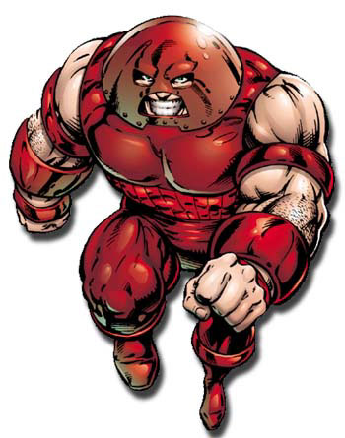
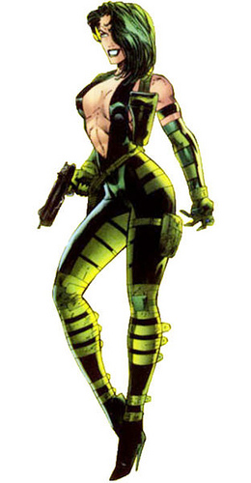
Juggernaut Cain Marko [Secret]
Affiliations
Solo
Buddy
Team
Distinctions
Anger Issues
I’m the Juggernaut, B*&%#!
Not Like My Brother

Power Sets
Avatar of Cyttorak
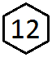 Godlike Durability Psychic Resistance
Superhuman Shapeshifting Godlike Strength

SFX: Collateral Damage. Instead of spending d6, add d6 to the doom pool to create an Avatar of Cyttorak stunt.
SFX: Immunity. Spend d6 to ignore stress or trauma caused by starvation or suffocation.
SFX: Invulnerable. Spend d6 to ignore physical stress or trauma unless caused by psychic attacks.
SFX: Unstoppable. Step up or double any Avatar of Cyttorak power for one action. If that action fails add your effect die to the doom pool.
Limit: Mystical Helmet. Shutdown Psychic Resistance and step up or add d6 to the doom pool. Spend d6 from the doom pool to recover.

Specialties
Combat Expert Crime Expert Menace Expert Mystic Expert

P M E

Diamond Lil Lillian Crawley-Jeffries [Secret]
Affiliations
Solo
Buddy
Team
Distinctions
Canadian Hero
Something to Prove
Untouchable

Power Sets
Impenetrable Bio-Aura
Superhuman Durability

SFX: Invulnerable. Spend d6 to ignore physical stress or trauma unless caused by psychic attacks.
SFX: Versatile. Replace your Superhuman Durability die with 2d8 or 3d6 on your next roll.
Limit: Mutant. Earn 1 PP when effected by mutant specific Milestones and tech.

Specialties
Combat Expert Crime Expert

P M E
This work is fan content. Word Template designed by Brian Liberge of StufferShack.com. Characters are property of their respective owners.

